Why MySQL?

* Open Source - MySQL is open-source software. You don’t have to spend a single penny to access its services.
* Cross-Platform - MySQL can run on Windows, Linux, Unix, and other operating systems.
* High Availability - MySQL possesses a high processing system that makes MySQL process bulk queries and transactions while ensuring unique memory caches.
* Reliability - SSH and SSL provide secure connections in MySQL. MySQL comes with features such as data encryption and data backup for recovery.

What is MySQL Workbench?

MySQL Workbench is a unified software used to add functionality and ease to SQL development work. MySQL Workbench provides [data modeling,](https://www.simplilearn.com/what-is-data-modeling-article) SQL development, and various administration tools for configuration. It also offers a graphical interface to work with the databases in a structured way.

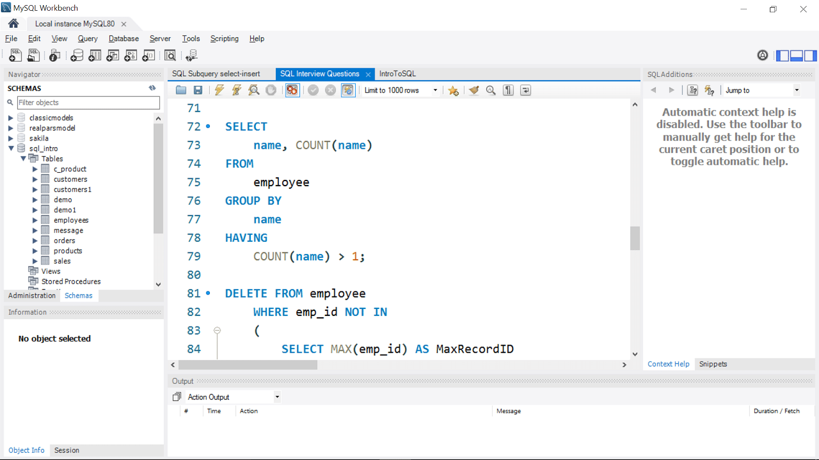

How to Install MySQL Workbench?

Moving on, you will look at how to install MySQL Workbench on Windows. The installation process is similar to other operating systems.

1. Open the MySQL website on a browser. Click on the following link: [MySQL Downloads](https://www.mysql.com/downloads/" \o "MySQL Downloads" \t "_blank).

2. Select the Downloads option.

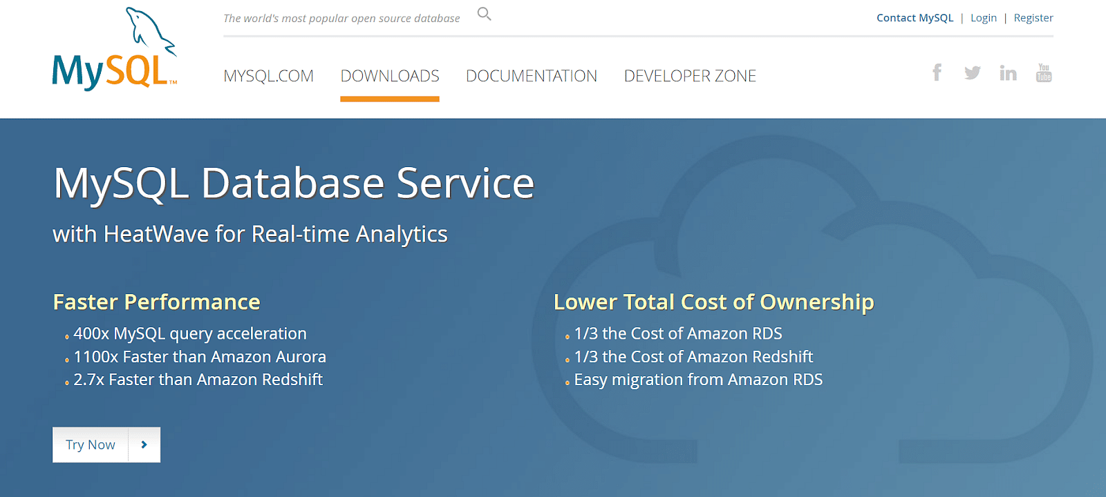

3. Select MySQL Installer for Windows.

4. Choose the desired installer and click on download.

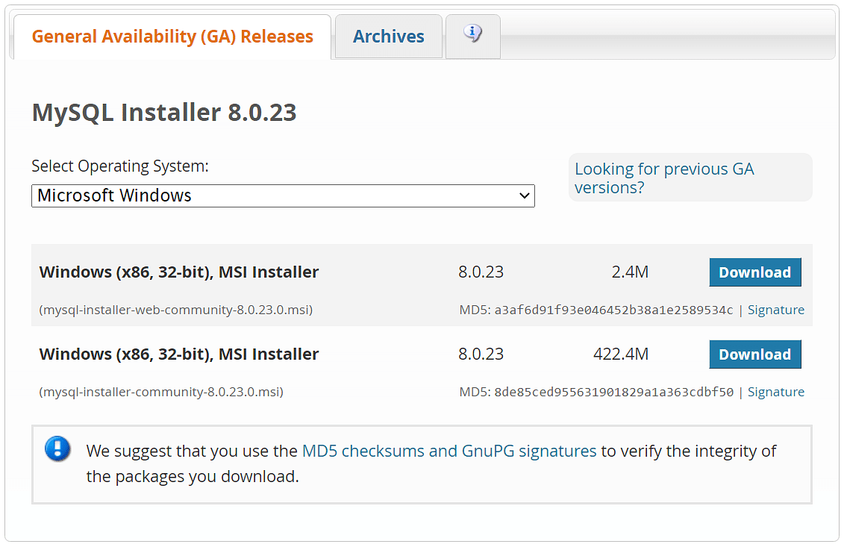

Front or Back-End Development? Learn It All!

Caltech Coding Bootcamp[EXPLORE PROGRAM](https://www.simplilearn.com/coding-bootcamp?source=GhPreviewCTABanner)

Front or Back-End Development? Learn It All!

5. After the download, open the installer.

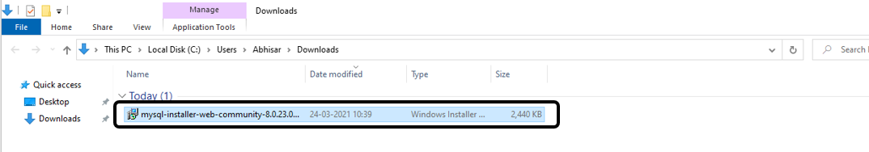

6. It will ask for permission; when it does, click Yes. The installer will then open. Now, it will ask to choose the setup type. Here, select Custom.

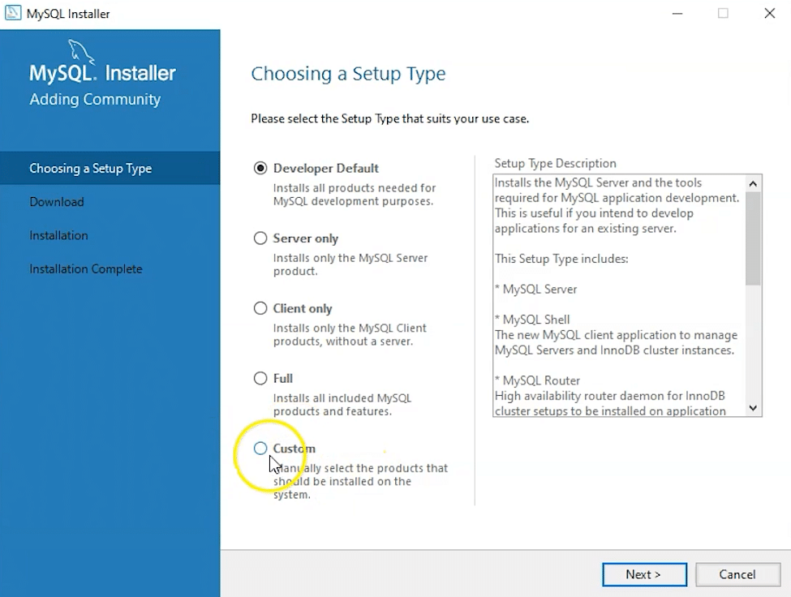

7. Click on Next. With this, you will install MySQL server, MySQL Workbench, and MySQL shell.

8. Open MySQL Servers, select the server you want to install, and move it to the  Products/Features to be installed window section. Now, expand Applications, choose MySQL Workbench and MySQL shell. Move both of them to ‘Products/Features to be installed’.

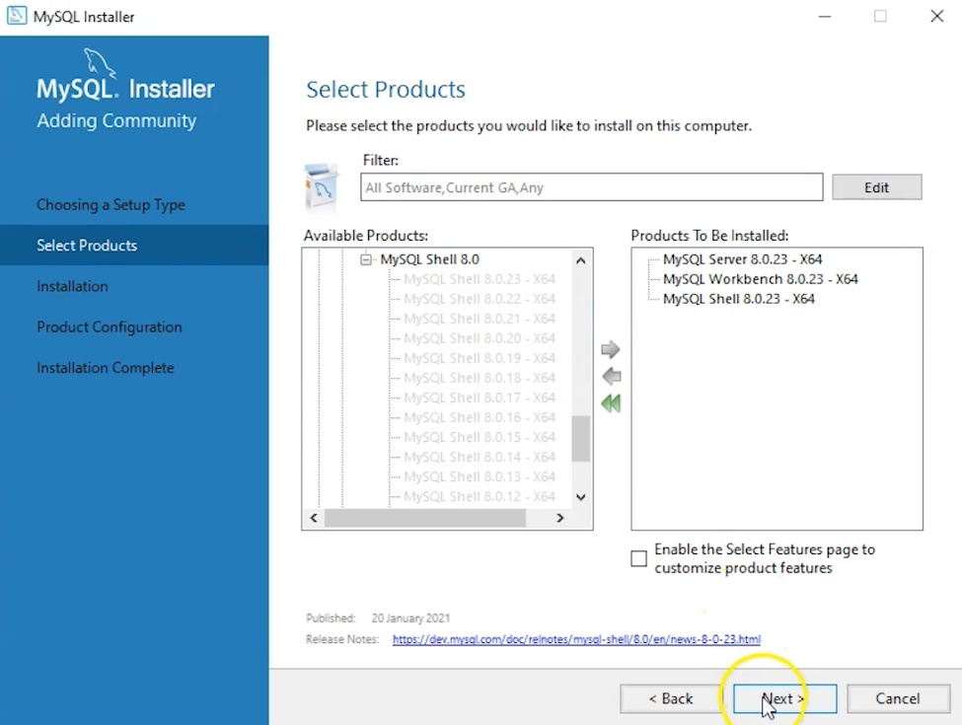

9. Click on the Next button. Now, click on the Execute button to download and install the MySQL server, MySQL Workbench, and the MySQL shell.

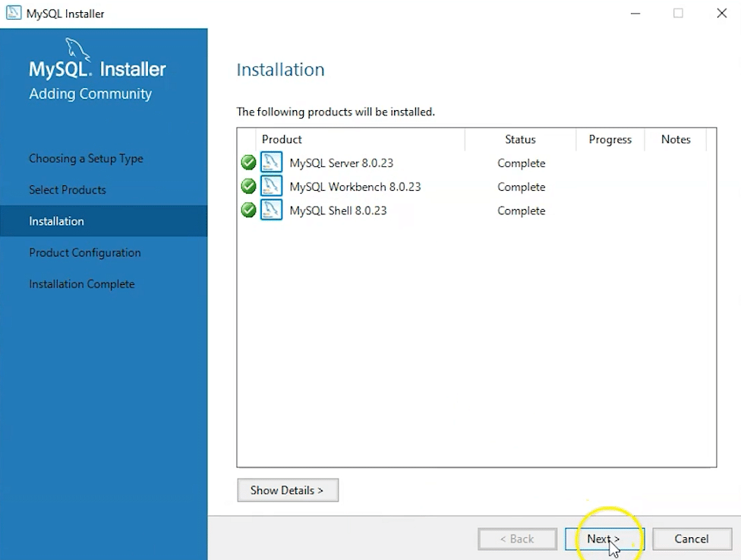

10. Once the product is ready to configure, click on Next. Under Type and Networking, go with the default settings and select Next.

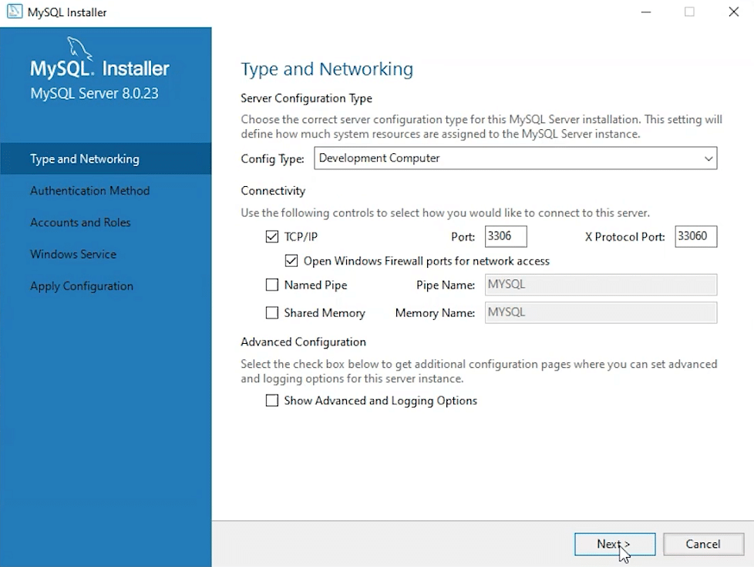

11. For authentication, use the recommended strong password encryption.

12. Set your MySQL Root password and click on next.

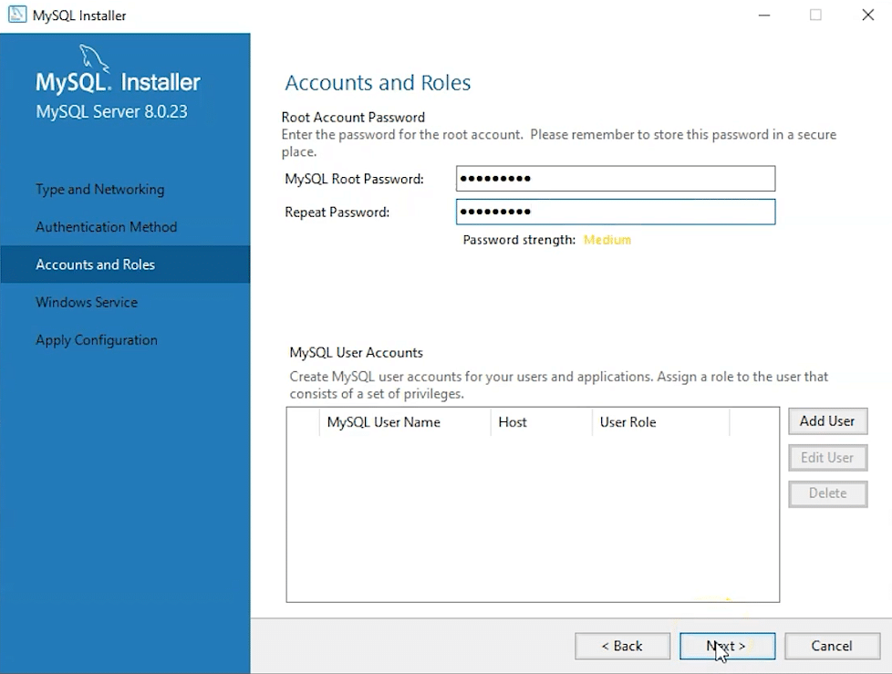

Learn How to Get Started in Blockchain

Free Webinar | 2 May, Tuesday | 9 PM IST[REGISTER NOW](https://www.simplilearn.com/learn-how-to-get-started-in-blockchain-webinar?utm_source=webinarpromo&utm_medium=FRS-banner&utm_campaign=May)

Learn How to Get Started in Blockchain

13. Go for the default windows service settings and under apply configuration, click on execute. Once the configuration is complete, click on finish.

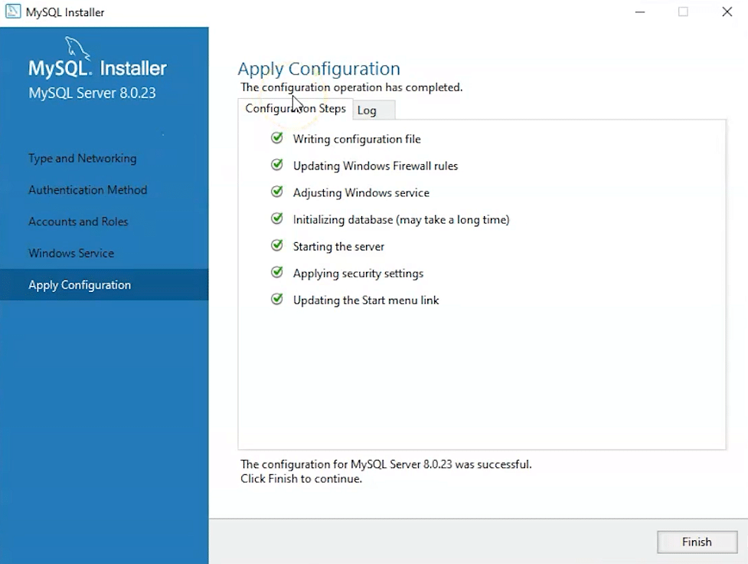

14. Complete the installation. This will now launch the MySQL Workbench and the MySQL Shell.

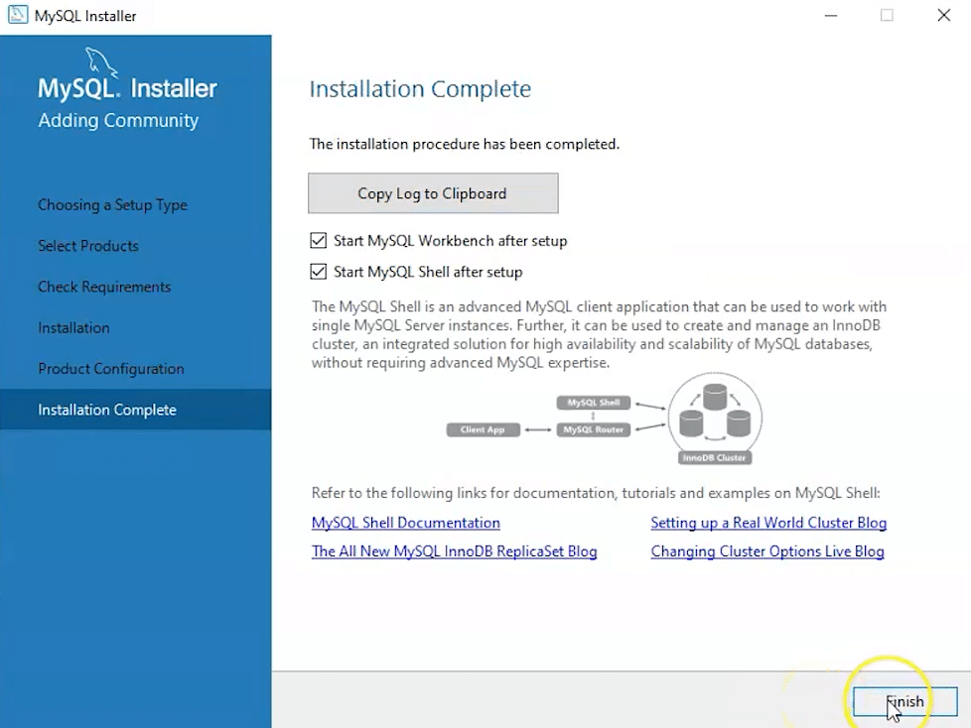

Once MySQL Workbench is installed, select the Local instance and enter the password.

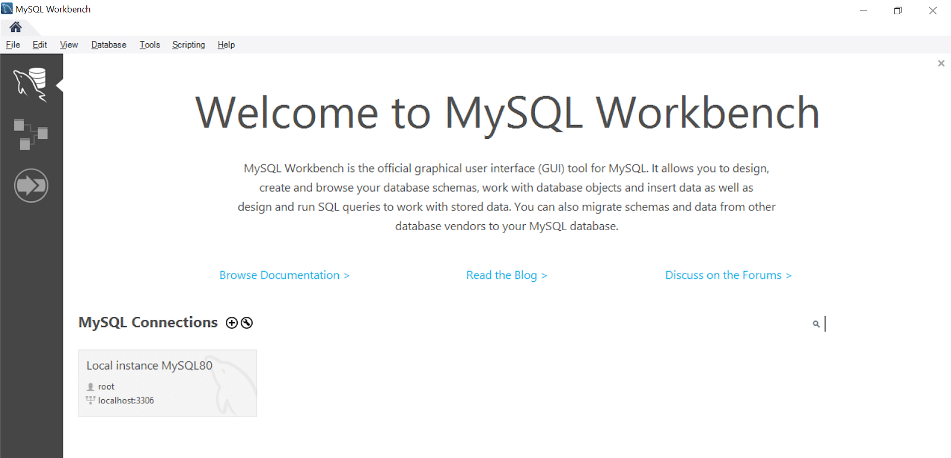

Now, you can use the MySQL query tab to write your SQL queries.

Get a firm foundation in Java, the most commonly used programming language in software development with the [Java Certification Training Course](https://www.simplilearn.com/mobile-and-software-development/java-javaee-soa-development-training?source=GhPreviewCTAText).

Conclusion

With its comprehensive features, MySQL Workbench is a popularly used software by businesses to manage their structured databases.

In this tutorial, you learned the steps to install MySQL Workbench on Windows.